**IT115 – Assignment Four - GitHub Website Activity Log**

**Tonight’s zoom meeting link:**

**Genet Gebru is inviting you to a scheduled Zoom meeting.**

**Topic: IT115 GitHub Website Meeting**

**Time: Oct 26, 2022 08:00 PM Pacific Time (US and Canada)**

**Join Zoom Meeting**

**https://us04web.zoom.us/j/73830805127?pwd=kyKL8W3EbHmXuP2aazSq1yie5RCw6R.1**

**Meeting ID: 738 3080 5127**

**Passcode: 18gTeM**

**Contacts:**

Nick: (253) 330 - 9734

Genet: (206)396-8141

Marissa: (206)235-2498

Jomar: jomarquiban17@gmail.com

Welcome Page Image:

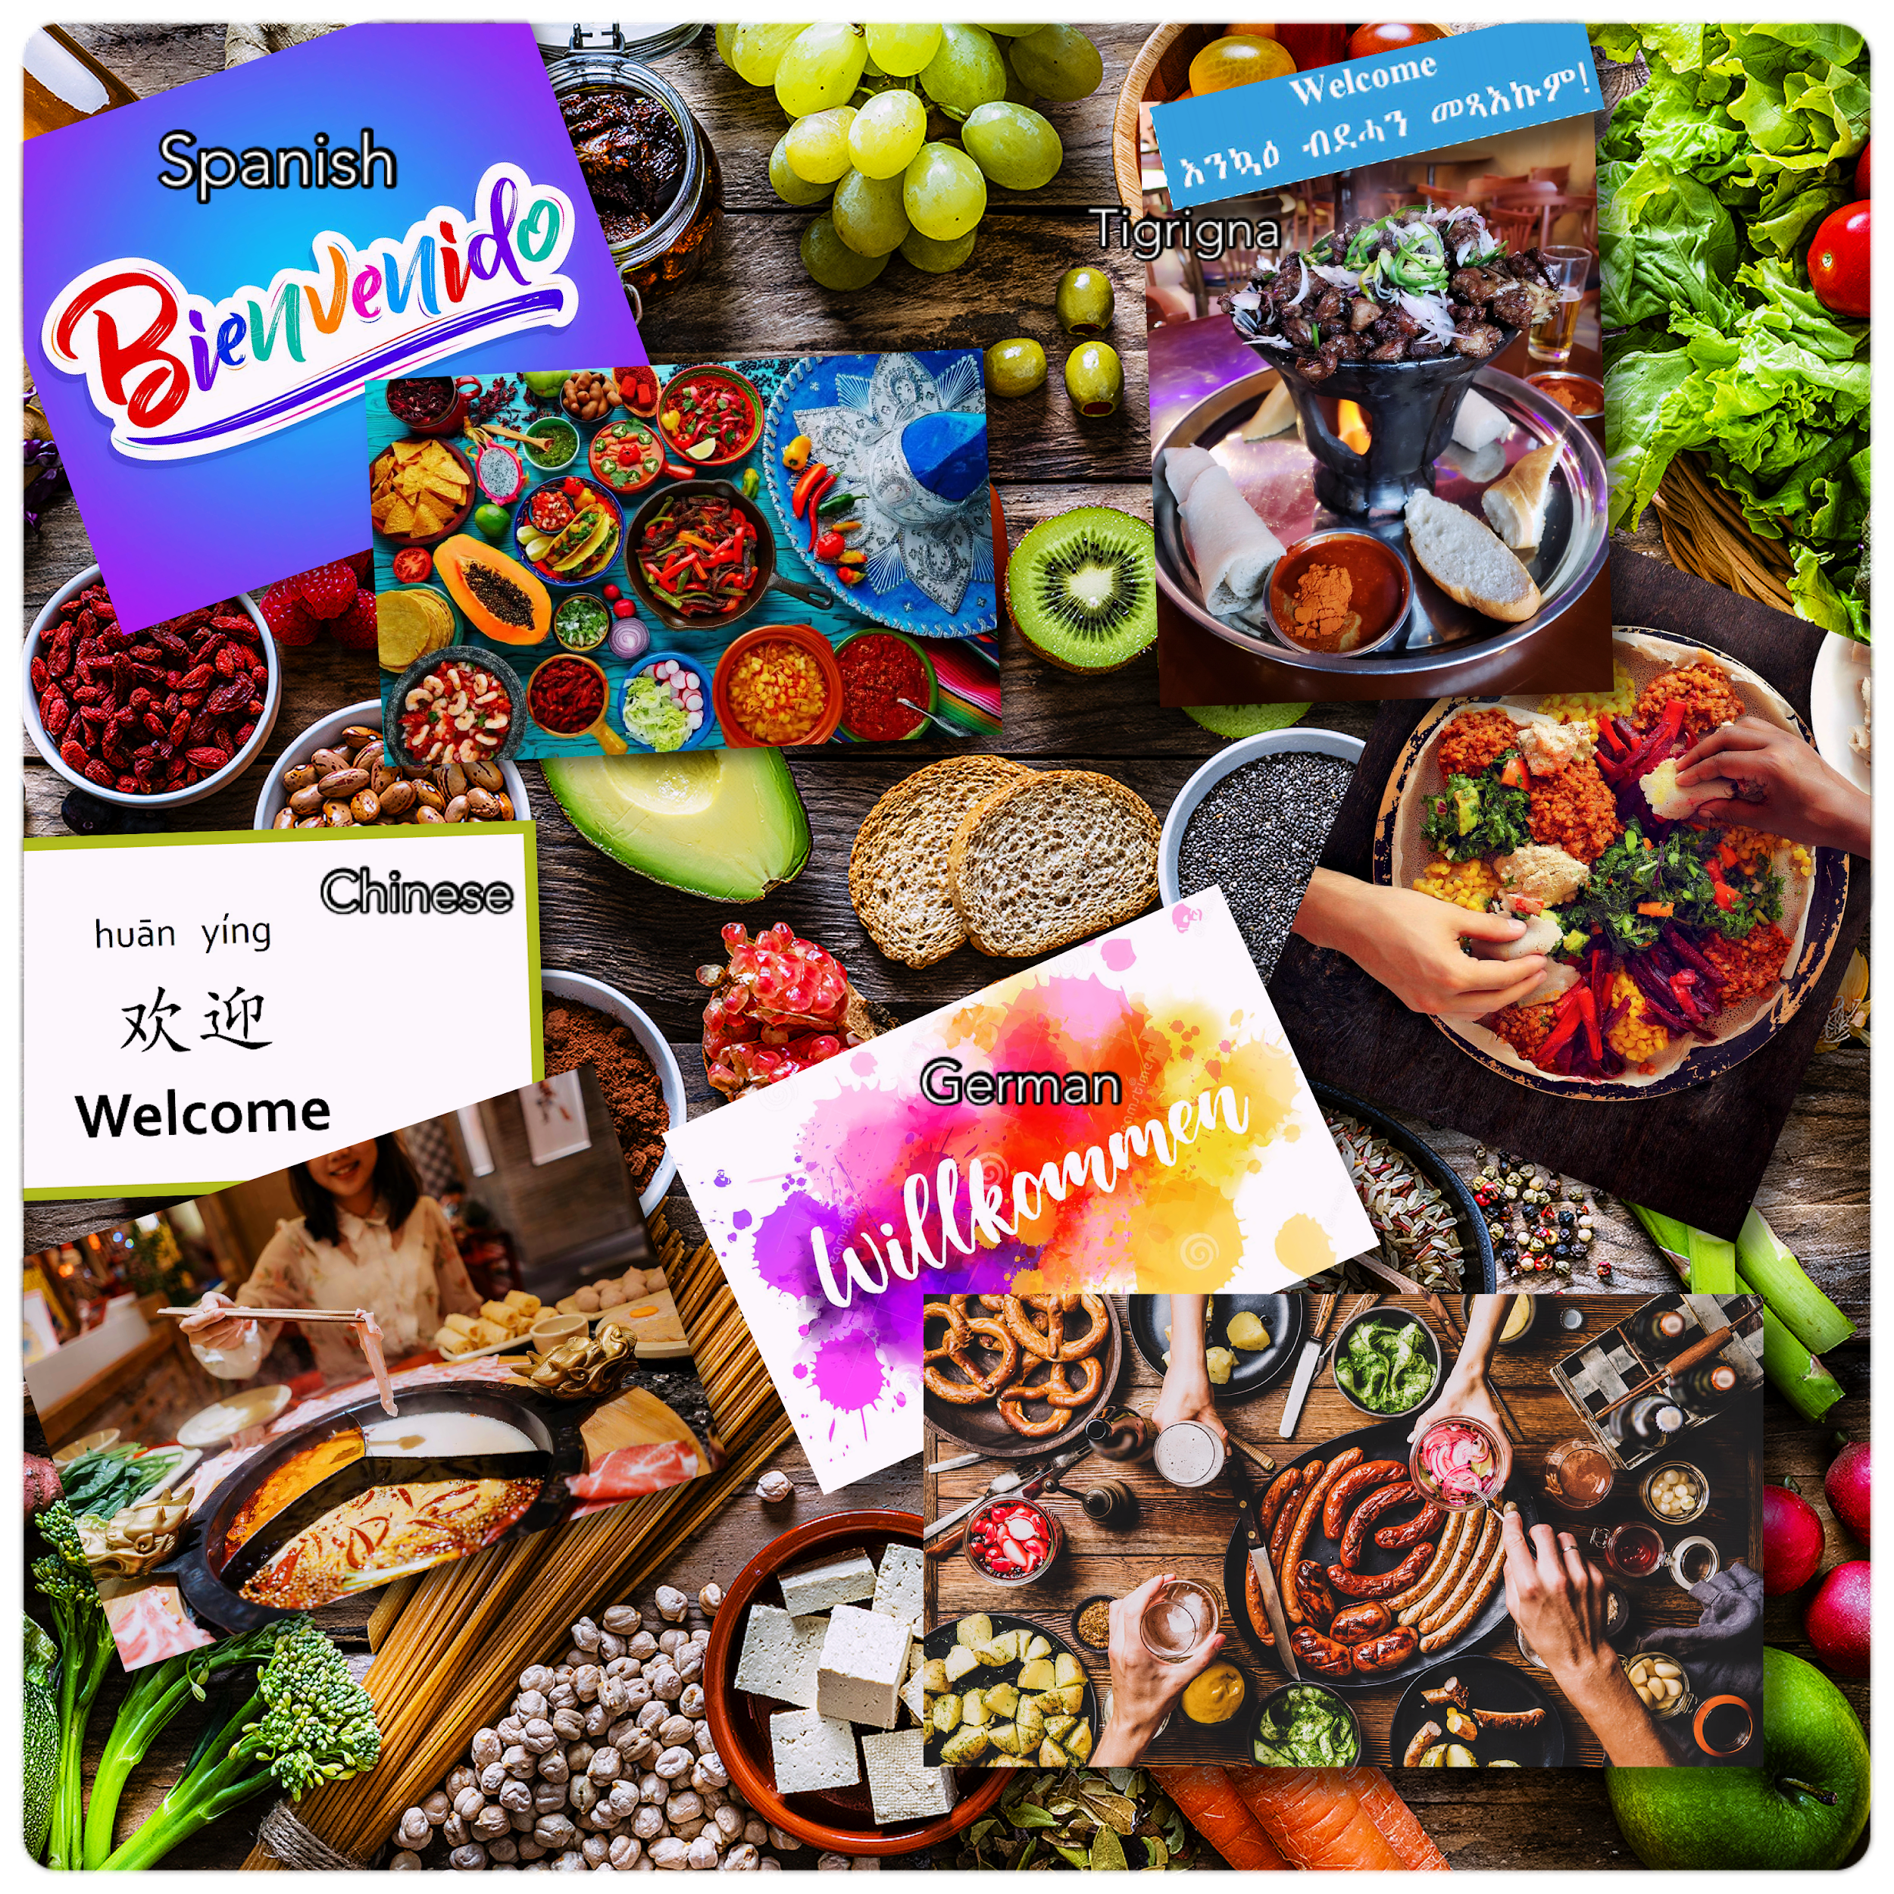

Introduction to Website:

How to say *‘Food’* in International Languages:

English: Food

German | Germany: Lebensmittel

Chinese | China: 食物 (Shíwù)

Spanish | Mexico: Alimento

Tigrigna | Tigray: Mig’bi

You are completely in for a weekly treat as we bring you the best there is of the 4 TOP-rated restaurants of the week! We’ve even managed to gain our personalized copy of these magnificent restaurant recipes for you to try at home from no other… wait for it…the Restaurant owners themselves — What a delightful treat!

Check out the links above for the top 4 picks of the week! Be sure to tune in next week to see the next top picks!

Recipes for Healthy Living, the Taste of Home Cooking, Entertaining Friends are provided for you (for free) within the links below.

Oh, don’t forget to try these recipes at home!

List of Ingredients and Instructions to create delicious meals all at your fingertips.

Take a peek and put a touch or pinch of whatever to make it your very own 😋 Enjoy!

**Team members and Roles:**

**Assignment 4 Group Project: Github Web Page - Group #2:**

1. **Genet Gebru:**
   1. Ethiopian Restaurant
   2. Google Doc Owner/Team Coordinator
   3. Content Reviewer/Editor

Restaurant name: **Genet’s WERKI TIGRAY**



![image](https://user-images.githubusercontent.com/93103705/197274054-ef0b9a9f-4329-4a73-be4d-7ba98aa47e87.png)

![image](https://user-images.githubusercontent.com/94158648/197668409-2821da51-b1d6-447e-86f1-a4442d8a084f.png)

![image](https://user-images.githubusercontent.com/94158648/197668604-4baad64f-c021-44d2-a01c-5c2d9aeefe55.png)

![Ashenda Tigray](https://user-images.githubusercontent.com/94158648/142278055-6b75684a-9ebe-4e90-8e20-d4fc7d16d7e4.jpg)

# Delicious Delicacies by GENET'S TIGRAY RESTAURANT:

#Dish#1 — Tihlo



![Tihilo](https://user-images.githubusercontent.com/94158648/142278022-d6ae65f6-3c4d-4879-9161-55d9c3003ac6.jpg)

Genet's Favorite Traditional Dishes from her hometown of Adigrat, Tigray: Tihilo

'Tihlo (Tigrinya: ቲህሎ) is a dish from the historical Agame province in Northern most parts of Ethiopia that consists of barley dough balls covered with meat and berbere (berbere is made of chili after is is dried and powdered) based sauce often served as a snack. Tihlo is commonly consumed as a side dish or snack, especially in Ethiopia's northern communities, specifically the Tigray people. The barley grain is completely dehulled and milled. Tihlo is made using moistened roasted barley flour that is kneaded to a uniform consistency. The dough is then broken into small balls and laid out around a bowl of spicy meat stew. A two-pronged wooden fork is used to spear the ball and dip it into the stew. Tihlo is commonly served on cultural holidays.'

Dish#2 — Alicha



# Potato and Cabbage Dish. Inexpensive ingredients, but healthy, rich in flavor, texture and Tumeric aroma - A soup and A stew!

The vegetables are roughly cut so that they maintain their shape and soak up the garlicky, spicy, gingery broth.” This recipe will yield more of the spicy condiment awaze than you need, but you can use what’s leftover in almost any other soup or stew, or mix it into mayonnaise to punch up your next sandwich. It even makes a great marinade for chicken or fish.

Ingredients

8 Servings

AWAZE

6 medium red or green jalapeños, coarsely chopped

1 small dried chile de árbol

2 garlic cloves

1 1" piece ginger, peeled, thinly sliced

1 cup (packed) cilantro leaves with tender stems

1 Tbsp. plus 1½ tsp. extra-virgin olive oil

2 tsp. Diamond Crystal or 1¼ tsp. Morton kosher salt

STEW

¼ cup vegetable oil

5 large onions (about 2½ lb.), thinly sliced

3 large carrots (about 1½ lb.), peeled, sliced on a diagonal ¼" thick

6 medium Yukon Gold potatoes (about 2½ lb.), peeled, halved, each half cut crosswise into 3 pieces

½ large head of green cabbage (about 1½ lb.), cut into 12 wedges

1 medium green jalapeño, coarsely chopped

1 medium red or green jalapeño, finely chopped

3 garlic cloves, coarsely chopped

2 Tbsp. Diamond Crystal or 1 Tbsp. plus ½ tsp. Morton kosher salt

1½ tsp. ground turmeric or 1 Tbsp. finely grated peeled turmeric

![image](https://user-images.githubusercontent.com/94158648/197665009-fe5b294d-e5ad-46d3-98f2-694120cfa4f5.png)

Served Vegan or add a bit of meat for meat lovers - Perfect combination – YUM!

#Dish #3: Healthy Meals to Fuel Your Day:

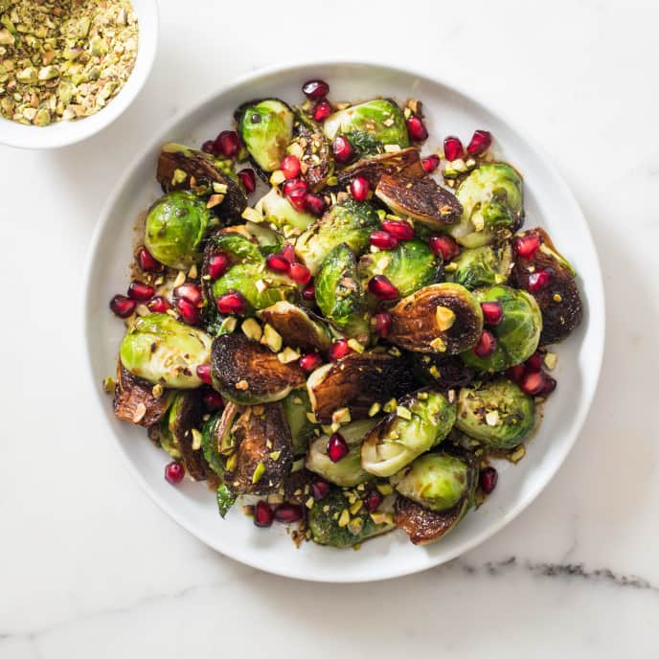

![brussels sprouts with pp](https://user-images.githubusercontent.com/94158648/141927117-5187f130-6cd6-439f-a767-6dcc4755f4fb.jpg)

'Skillet-Roasted Brussels Sprouts with Pomegranate and Pistachios'

[Brussel Sprouts With Pistachios Recipe](https://github.com/Tigray11/IT100-Recipe-/blob/main/Skillet-Roasted%20Brussels%20Sprouts%20With%20Pomegranate%20and%20Pistachios)

Reviews:

#1: Rahwa Shikor

Dinish/Potato Dish was spectacular! Leaves a tinted yellow stain on your nails, since you have to use your hands to eat with the Flat-Sour-Bread. It was Amazing! Recommend Genet’s Werki Tigray Restaurant to anyone craving a spicy, mouth watering, healthy meal!

#2: Mercy Love

Hi, Mercy here. My mom makes me eat here, — she’s the restaurant owner. She says it’s healthy for you and says if I don’t eat here no one will. She’s making me write a review too, but I guess I want to, do I’m here. Let me tell you, Tihlo (Tigray’s traditional dish) is my FAVORITE and you should totally try it, especially with a group of at least five friends, if you don’t have five friends grab some folks you’ll meet at our restaurant and share. Trust me, you won’t be able to finish this dish on your own. By the way it’s very spicy, so make sure you dip the ‘Tihlo’ into the yogurt that’s in the middle of the meat and spices stew and you’ll love it! Go on, order my favorite: ‘Tihlo’ and get a taste of Tigray, our beautiful homeland — you will NOT be disappointed!

#3: Kidu’ Love

Yo college students - want cheap, but healthy food? Genet’s WERKI TIGRAY restaurant is it! It’s simply ‘Golden’ just like its name (‘WERKI’ means ‘Golden’ in language: Tigrigna) anyway, they have the most amazing food. I’m a college student, I can’t cook, I hate the kitchen, my mom’s too far to cook for me, so until I can afford to hire a cook — Werki Tigray restaurant is it. I love their spicy Ethiopian food and even my mom agrees how healthy it is when she visited me last, so this restaurant is literally my second home. I highly recommend it!

________________________________________________________________________  
________________________________________________________________________

1. **Marissa Dashen:**

Restaurant Name: Das Schnitzel Haus

Recipe:**Hasenpfeffer-Rabbit-Stew**

A savory stew made by marinating and braising rabbit in spices and vinegar.

Ingredients:

One large rabbit, dressed, and cut into pieces

½ cup flour

½ teaspoon garlic powder

½ teaspoon onion powder

¼ cup olive oil

1 teaspoon salt

½ teaspoon pepper

½ teaspoon allspice or cloves

1 medium-sized onion

5 cloves garlic, peeled and sliced

2 bay leaves

½ cup vinegar

1 can tomato puree

Directions:

Combine garlic powder, onion powder, and flour.

Roll pieces of meat in flour mixture, and fry in the oil until golden brown.

Place the fried meat in a Dutch oven with the sliced onion, garlic, allspice, bay leaves, salt, pepper, vinegar, and tomato puree.

Bake at 350 for 1 to 1.5 hours.

**Das Schnitzel Haus Reviews**

**About Us:**

Welcome to Das Schnitzel Haus. We pride ourselves on serving traditional German

comfort food since 1890. We offer nightly musical entertainment for your enjoyment as

well as an outdoor beer garden. Our 5,000 square foot game room includes an axe

throwing area, bocce ball court, and pool tables. Our Oktoberfest celebrations feature

an annual lumberjack competition. So join us for a tasty bite and a mug of ale.

**Review #1 from Hazel J.**

**\*\*\*\***

**3 days ago**

My friend and I ate at this establishment the other day and I was very

impressed. I ordered the hasenpfeffer which is a rabbit stew braised in a tangy sauce

and my friend ordered the cheese dumplings with mushroom broth. I have no

complaints about the food because it was exceptionally delicious.

Our only complaint is that this restaurant is located next to a farm, and we

happened to be dining on the outdoor patio. We were surrounded by a flock of about

10-12 chickens that would not stop pestering us for food.

Overall, the food was great, and I would eat here again, but I recommend dining

indoors. I took one star off for the unruly chickens.

**Review #2 from Dottie D.**

**\*\***

**2 months ago**

I dined here this evening, and I have to say the customer service here is

awful. I ordered rabbit stew with mashed potatoes and a large mug of ale to wash it

down. The food arrived quickly, and the portion was enormous. The food was a bit

bland and the ale was so watery, it had no flavor. The ale tasted like water that is

pretending to be beer. Anyways, I finished eating and waited a very long time to receive

my check. The grumpy server kept scowling at me from afar, perhaps because I had so

much food leftover.

**Review #3 from Klaus L.**

**\***

**1 year ago**

I regret getting takeout from here. The food was gross and overpriced for

what I got. I ordered the hasenpfeffer stew and they left the bones in the meat. Very

difficult to eat when on the go. Also the owner and the servers were rude. I would give

them negative stars if I could.

**Response from the owner**

Hello Klaus, thank you for your review. We regret that you had a bad

experience here at our restaurant, but leaving a bad review because you didn’t

like the dish you ordered is not very nice. We hope your day gets better.

Das Schnitzel Haus Images:

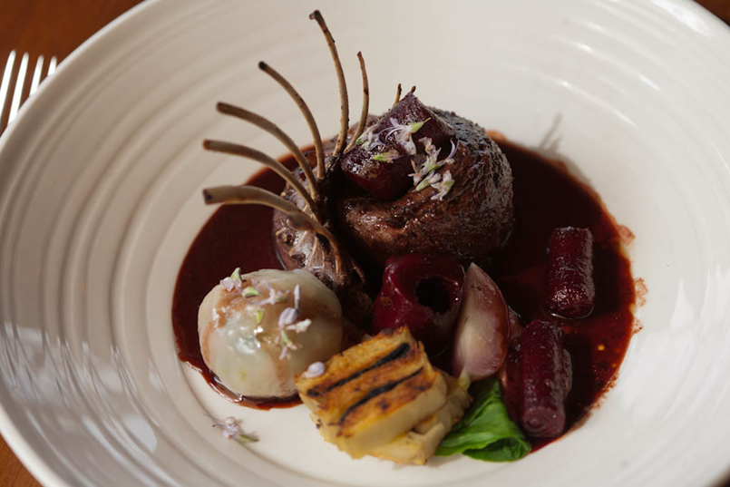

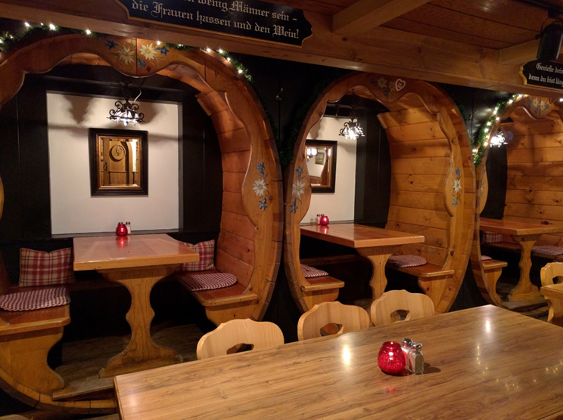



____________________________________________________________________________________________________________________________________________________

1. **Nick Vialpando:**

Restaurant name: El Picante Pachanga

Recipe:

1 recipe goes here

Reviews:

3 reviews —

Images:



* 1. Mexican Restaurant
  2. HTML/CSS DocumentLead
  3. Content Reviewer/Editor

____________________________________________________________________________________________________________________________________________________

1. **Jomar Quiban:** 
   1. Chinese Restaurant: Wok-it-Out

**Special Recipe: Xiao Long Bao**

**INGREDIENTS:**

* Pork stock jelly:   
  500 g pork bones
* *(blanched)*
* 2 stalks spring onion
* 4 slices ginger
* 1½ tbsp chicken stock concentrate or powder
* 2 tbsp Shaoxing wine
* 1.5 L water
* 10 g gelatin
* 60 ml cold water
* Pork Filling:  
  500 g fatty minced pork
* 3 stalks spring onion
* *(chopped)*
* 20 g ginger
* *(minced)*
* ½ tbsp light soy sauce
* ½ tbsp sesame oil
* ½ tsp salt
* ½ tsp sugar
* ½ tsp white pepper
* 2 tbsp cornstarch
* Pork stock Jelly
* 1 packet dumpling wrappers
* *(round shape)*

**INSTRUCTIONS:**

### Make Pork Stock

* In a pot, add blanched pork bones, spring onion, ginger, chicken stock, Shaoxing wine and water.
* Bring the stock to boil and then simmer for at least 30min for flavour of pork bones to infuse into the stock.
* Remove from heat, drain off ingredients and set stock aside.

### Prepare Gelatinand make Pork Stock Jelly

* Add gelatin to cold water and mix well. Allow gelatin to bloom.
* Add bloomed gelatin into the hot stock and whisk until gelatin fully dissolves.
* Pour stock into a container and chill for at least 6hrsor until fully set. *(If you are in a rush, you can put the container in the freezer instead. It will take 2-3 hrs.)*

### Prepare Pork Filling

* In a mixing bowl, add minced pork, spring onion, ginger, light soy sauce, sesame oil, salt, sugar, pepper and cornstarch, and mix well.
* Remove the pork stock jelly from the chiller and cut into small pieces. Add the pork stock jelly to the pork fillingand mix well.
* Set aside filling in fridge if not use *(as the pork stock jelly can melt at room temperature).*

### Wrap Xiao Long Bao

* Take a piece of dumpling wrapper. You may roll it thinner at the edges if desired.
* Fill each wrapper with 16g of filling.
* Fold the xiao long bao by pleating and lightly pulling the edges repeatedly. When the xiao long bao is almost completely pleated, pinch the edges together and twist slight to seal it.

### Steam

* Line a bamboo steamer with a parchment paper (with holes) or a steaming cloth, and place the xiao long baos into the steamer.
* Bring a pot to boil, then steam the xiao long baos for about 4-5 min.
* Remove bamboo steamer from the pot.

### Garnish and Serve!

Serve the xiao long baos hot. Dip with black vinegar and julienned ginger.



***Wok-it-Out About Us:***

In need of being the next Panda King? Don't worry, our Xiao Long Bao is the best we got for you with different varieties of it. Wok-it-Out is a Chinese Restaurant that has been serving since 2010. We pride ourselves for being the best restaurant around South East Asia. Our menu is not only Xiao Long Bao but mostly made out of Chinese taste which you could experience only here at our restaurant. Come in now and grab your Xiao Long Bao and be the next “Xiao Long Bao Panda King” for eating one hundred pieces of it!

***Wok-it-Out Reviews:***

***4 months ago (****)***

It was overall a pleasant experience. Depending on your pallette the vinegar and soy dip was super delightful.

***6 months ago (*****)***

This will go down as one of my most favorite restaurants ever. For the price, it's definitely sulit!

Ratings out of 5 stars:

Pork Xiao Long Bao: 4.5 stars (one of the best xiao long baos I've ever tasted)

Shrimp and pork Shao Mai: 3.5 stars (nothing too special, it's good but you can go w/o it)

Shrimp and Pork wontons w/ House Soy Sauce: 5 stars (this was one of the faves honestly)

Wok-it-Out hot tea: 5 stars (if you're into tea, this is amazing. It's not too bitter and it goes down so smoothly - plus if you buy this, it's unli refill)

Salted Egg Yolk prawns: 5 stars (holy moly was this tasty! I cannot forget how good it tastes!!)

Noodles with House special spicy sauce: 4 stars (really good spice! tasty even if it's spicy)

Fried rice: 3 stars (cannot remember what specific rice we got - but again, nothing too special)

Choc.o lava xiao long bao: 5 stars!! (this was also soooo good! The chocolate was not too sweet but also not too bitter. If I'm being honest it got that Hot Choco Vibes. After a bite, the chocolate bursts in your mouth like a dream.)

The place was busy but the servers/wait staff were quick on their feet and really nice too. They were very clean. Another plus is they check vaccination cards before dine in so that's a plus for peace of mind

5/5 would recommend it and come again!!

***7 months ago (*****)***

They never miss! Great service, quality food, reasonable prices. Really love their Crab Roe xiao long bao. One of my favorite Chinese food restaurants to eat at.

* 1. Content Reviewer/Editor

**Link to Repo**: https://github.com/marissadashen/A4-Web-Page-Project.git

**Link to GitHub Page**: https://github.com/nvialp/it161-fall2022.git

**Time Log**: (Newest at top)

*10/26: Jomar reviewed the web page(10 minutes)*

*10/26: Jomar updated his recipe, content, and reviews(20 minutes)*

10/26: Nick updated htm files and folders to add page content for each restaurant, update main branch. (1 hour)\

*10/24: Marissa updated her recipe and chose new photos (30 minutes)*

*10/24: Marissa updated her recipe and chose new photos (30 minutes)*

*10/22: Marissa wrote restaurant reviews and sent them to Nick (1 hour)*

*10/22/2022: (Nick) Created page templates and uploaded the directory folder and files to github (1 hour)*

*10/21: Marissa created a Readme file on the repository (5 minutes)*

*10/20: Marissa created the repository on GitHub (1 minute)*

**Resources Accessed**:

<https://github.com/Tigray11/IT100-Final-Project---Recipes---Genet-Marissa-Renee.git>

<https://images.app.goo.gl/btFTnuNnDkUJz6TR8>

Due Next Thursday at Midnight

__________________________________________________________________________

**10/24/22**

GitHub Account Setup, Layout, Images, Content Draft

### A4-Web-Page-Project

Group 2 Assignment 4

This web page shares reviews of some new restaurants that have recently opened. Everything from food quality to staff friendliness will be discussed.

We hope you enjoy reading our detailed reviews.

Bon Appetit!

![image](https://user-images.githubusercontent.com/93103705/197274054-ef0b9a9f-4329-4a73-be4d-7ba98aa47e87.png)

Recipes for Healthy Living, Taste of Home Cooking, Entertaining Friends! Smell the aroma, create taste to your liking, devour meals you love and enjoy! List of Ingredients and Instructions to create delicious meals all at your finger tips. Take a peek and put a touch or pinch of whatever to make it your very own :)

![image](https://user-images.githubusercontent.com/94158648/197680255-82cbe7f0-6d04-455a-8991-2891a7f3dd63.png)

# Delicious Recipes to your delight

Bon Appétit! Recipes for Healthy Living, Taste of Home Cooking, Entertaining Friends! Smell the aroma, create taste to your liking, devour meals you love and enjoy!

![image](https://user-images.githubusercontent.com/94158648/197680406-9e23fc99-22cd-49f1-b85d-5ea882dcdfc4.png)

![wide-middle-eastern-food](https://user-images.githubusercontent.com/94158648/141925708-5e0eeef7-bc15-4913-aa6a-c52c8e9572d1.jpg)

List of Ingredients and Instructions to create delicious meals all at your finger tips. Take a peek and put a touch or pinch of whatever to make it your very own :)

![Ashenda Tigray](https://user-images.githubusercontent.com/94158648/142278055-6b75684a-9ebe-4e90-8e20-d4fc7d16d7e4.jpg)

# Recipes by GENET's TIGRAY RESTAURANT:

![Tihilo](https://user-images.githubusercontent.com/94158648/142278022-d6ae65f6-3c4d-4879-9161-55d9c3003ac6.jpg)

Genet's Favorite Traditional Dishes from her hometown of Adigrat, Tigray: Tihilo

'Tihlo (Tigrinya: ቲህሎ) is a dish from the historical Agame province in Northern most parts of Ethiopia that consists of barley dough balls covered with meat and berbere (berbere is made of chili after is is dried and powdered) based sauce often served as a snack. Tihlo is commonly consumed as a side dish or snack, especially in Ethiopia's northern communities, specifically the Tigray people. The barley grain is completely dehulled and milled. Tihlo is made using moistened roasted barley flour that is kneaded to a uniform consistency. The dough is then broken into small balls and laid out around a bowl of spicy meat stew. A two-pronged wooden fork is used to spear the ball and dip it into the stew. Tihlo is commonly served on cultural holidays.'

# Potato and Cabbage Dish.

Inexpensive ingredients, but healthy, rich in flavor, texture and Tumeric aroma - A soup and A stew!

Served Vegan or add a bit of meat for meat lovers - Perfect combination.

Other Healthy Meals to Fuel Your Day:

![brussels sprouts with pp](https://user-images.githubusercontent.com/94158648/141927117-5187f130-6cd6-439f-a767-6dcc4755f4fb.jpg)

'Skillet-Roasted Brussels Sprouts with Pomagranate and Pistachios'

[Brussel Sprouts With Pistachios Recipe](https://github.com/Tigray11/IT100-Recipe-/blob/main/Skillet-Roasted%20Brussels%20Sprouts%20With%20Pomegranate%20and%20Pistachios)

![Pesto pasta](https://user-images.githubusercontent.com/94158648/141927156-0e839623-7509-4407-a353-7012a594c34f.jpg)

'Broccoli-Walnut Pesto Pasta'

[Pesto Pasta Recipe](https://github.com/Tigray11/IT100-Recipe-/blob/main/Nuts%20for%20Broccoli-Walnut%20Pesto%20Pasta)

![Almond Tea Bread Recipe](https://user-images.githubusercontent.com/94158648/141927166-0fe25bc4-1eb0-4b0c-a972-03957c85cd4d.jpeg)

'Almond Tea Bread'

[Delicious Almond Tea Bread Recipe to your liking - Follow these easy steps and add your favorite flavors](https://github.com/Tigray11/IT100-Final-Project---Recipes---Genet-Marissa-Renee/blob/main/Almond%20Tea%20Bread%202)

![chili](https://user-images.githubusercontent.com/94158648/141927358-62eb81cf-83b5-4d66-a92c-8c1a51212ca9.png)

'Chili'

[Chili Recipe](https://github.com/Tigray11/IT100-Recipe-/blob/main/Making%20Delicious%20Chili)

![Salmon](https://user-images.githubusercontent.com/94158648/141931713-fb02fab3-b75c-4929-9614-481a02e08b9f.jpg)

'Fresh Salmon'

[Salmon Recipe](https://github.com/Tigray11/IT100-Final-Project---Recipes---Genet-Marissa-Renee/blob/main/Fresh%20Salmon)

# Additional Recipes for you to Enjoy with your Family and Friends!

![Long table dinner](https://user-images.githubusercontent.com/94158648/142280899-670f7bda-0b62-4bb4-8fa4-c9520bb0c6ae.jpg)

**# FINE DINING WITH CHEF MARISSA:**

![MarissaChefOutfit](https://user-images.githubusercontent.com/93103705/144161901-c32657a9-3b1f-4560-903c-017356fac8cd.jpg)

![hasenpfeffer stew](https://user-images.githubusercontent.com/93103705/144162388-3c368475-8c56-4bb8-89e9-8ff413831d08.jpg)

[Rabbit Stew Recipe](https://github.com/marissadashen/Hasenpfeffer-Rabbit-Stew.git)

![yakh-dar-behesht Rosewater Custard](https://user-images.githubusercontent.com/93103705/144162439-5c312455-31fc-4f28-938d-9eb412707041.jpg)

[Rosewater Custard Recipe](https://github.com/marissadashen/Rosewater-Custard.git)

![Pecan Butter Sauce Fish](https://user-images.githubusercontent.com/93103705/144162477-b2e8eb04-b6f6-4f9e-bc62-e0001c22c516.jpg)

[Pecan Butter Sauce Recipe](https://github.com/marissadashen/Pecan-Butter-Sauce.git)

![Cottage Cheese Dumplings](https://user-images.githubusercontent.com/93103705/144162512-4ea4ab80-a699-4ad6-9256-808c9d21558f.jpg)

[Cottage Cheese Dumplings Recipe](https://github.com/marissadashen/Cottage-Cheese-Dumplings.git)

![Callaloo](https://user-images.githubusercontent.com/93103705/144162540-0719678f-c69c-451e-b8e5-55d62d7a7248.jpg)

[Callaloo Recipe](https://github.com/marissadashen/Callaloo.git)

![cooking-for-beginners-cooking-techniques-and-tips](https://user-images.githubusercontent.com/94158648/142270571-6e8b12ff-20f5-4ff2-a44f-1eec19cfe49f.jpg)

![Dinnerparty](https://user-images.githubusercontent.com/94158648/142280928-9fed48dd-987e-4968-b03c-f97834fe93d1.jpg)

![Dessert_Recipe_Custard_Jelly_Biscuit_Pudding-2](https://user-images.githubusercontent.com/94158648/142275350-8da0817e-2626-4050-86f7-135c49217a76.jpg)

![desserts](https://user-images.githubusercontent.com/94158648/142275404-23fcfadc-feb8-4130-99e6-c6096daedace.jpg)

**# Mexican + Samoa Remix Delight by Nicholas**

![Samoan-People-and-Their-Culture-1](https://user-images.githubusercontent.com/94158648/142278208-243bb295-1f4f-4593-b08d-7ec1adf4a0bf.jpg)

![Samoan Culture 2](https://user-images.githubusercontent.com/94158648/146057157-f25487b0-cb2e-43ab-a751-465d2267159c.jpg)

![Culture last](https://user-images.githubusercontent.com/94158648/146056976-1fc3eac1-3b4c-413a-9328-c7d8be859c50.jpg)

Young taro leaves (make sure that the stem is still green, if it’s red, do not use it) You will need 4 – 6 leaves for each serving, depending on size. So, if you are making 8 servings, you will need 32 – 48 leaves.

2 cans of creamy style coconut milk (if you cannot find ‘creamy’ you can use standard coconut milk)

One medium to large onion, chopped

Salt, to taste (as you can see, I used a wonderful Hawaiian salt)

Pepper (optional)

2 cups water

In a bowl, mix together the coconut milk, onions, salt and pepper

Take the washed and dried taro leaves and begin building a bowl on the palm of your hand. Notice how fresh these young leaves, straight off the plant, are. Leaves from the store tend to be a bit more ragged, but they still work.

Using the largest leaf on the bottom, begin stacking leaves on top, each smaller than the other. You will want to use 4 – 6 leaves each serving.

Now, spoon the coconut milk mixture into the bowl of the taro leaves. Fill it up about half way, maybe a cup or so, but not so much that it overflows when you wrap it.

For true island flavor, Samoan palusami is cooked in an umu, but most cooks do not have a pit oven available. Not to worry! An electric steamer is the most common method for many Polynesian families, and it makes the dish guaranteed tender! Simply place prepared palusamis in the steamer with the required amount of water and cook for at least 4 hours or more.

![Renee's Culture 1](https://user-images.githubusercontent.com/94158648/146057278-83e111b5-771e-4e80-8559-21fdf177d26b.jpg)

# Recipe to Enjoy!

![mexican 2](https://user-images.githubusercontent.com/94158648/142275581-76d0670f-a585-4341-9ef6-2d109121c9f4.jpg)

![Chicken Tinga](https://user-images.githubusercontent.com/94158648/146058437-7ab8b5f5-ad4f-4456-8789-0ca730e40deb.jpg)

[Chicken Tinga Recipe](https://github.com/rtautua1827/Chicken-Tinga-Recipe.git)

![Renee's Rice](https://user-images.githubusercontent.com/94158648/146058054-f9249de9-7cb1-46ea-9eb2-796d662c26d8.jpg)

[Authentic Mexican Rice Recipe](https://github.com/rtautua1827/Authentic-Mexican-Rice-Recipe.git)

![Renee's Flan](https://user-images.githubusercontent.com/94158648/146057698-a7271086-2e18-42c5-aae5-b65630c1df5c.jpg)

[Mexican Flan](https://github.com/rtautua1827/Mexican-Flan.git)

![Renee's Beans](https://user-images.githubusercontent.com/94158648/146057873-621772a8-63e3-40a1-ad6e-4348015caa29.jpg)

[Mexican Beans](https://github.com/rtautua1827/Mexican-Beans.git)

![Renee's Arroz Con Leche](https://user-images.githubusercontent.com/94158648/146058288-7c025a62-8f44-4a91-98cc-f5e823dc470f.jpg)

[Arroz Con Leche](https://github.com/rtautua1827/Arroz-con-leche.git)

![samoa food](https://user-images.githubusercontent.com/94158648/142275455-ca04e30a-ba44-4cf7-b20f-ded9cf2b5a85.JPG)

![mexican](https://user-images.githubusercontent.com/94158648/142275509-898f3b1a-a51f-4577-ba07-d914a4148062.jpg)

![Mango-Cream-Tart_EXPS_JMZ18_224490_D03_08__5b](https://user-images.githubusercontent.com/94158648/142275633-1d09d581-9ab2-44af-9aaf-3d255dc09052.jpg)

![Samoan](https://user-images.githubusercontent.com/94158648/142279443-5da67092-563b-45be-be3a-28aec3c72776.jpg)

**# Wok-It-Out with Jomar**

# DIG IN!

![Serving Dinner](https://user-images.githubusercontent.com/94158648/142281012-6a7e78c4-4672-4d61-af94-5f5c64e7a37d.jpg)

![Family_eating_meal_together_skynesher_Getty_Images](https://user-images.githubusercontent.com/94158648/142270434-ca902e90-de84-4323-8fba-d097cc52606f.jpg)

![christmas dinner](https://user-images.githubusercontent.com/94158648/142270474-2eee4c35-ccae-41b0-bf59-a2fd994e7501.jpg)

![family and friends dinner](https://user-images.githubusercontent.com/94158648/142281135-f7db40a4-4afa-4d03-840c-aea80f0697da.jpg)

![TRUTHTV-family-with-kids-1024x576](https://user-images.githubusercontent.com/94158648/142270622-5e038caa-10f3-4cf9-80b0-0aaeee4fe47c.jpg)

__________________________________________________________________________

# **21 OCT 2022**

Make the recipes page into a website site contents:

Home page Review and Recipe site from favorite restaurants - restaurant name,

Recipe page - add recipe from fake restaurant

Reviews added to recipe page after recipe - focus on silly reviews

Recipes: choice - german, ethiopian, somaoan, mexican, chinese

Restaurant 1 (Das Schnitzel Haus) - Marissa - German

Restaurant 2 (update fake restaurant name) - Genet - ethiopian

Restaurant 3 (Wok-it-Out) - Jomar - chinese

Restaurant 4 (El Picante Pachanga) - Nicholas - mexican

**THURSDAY, 10/20/22**

Wiki Prentations:

Branching, Pull-Requests, Merging due

[A4: Github Web Page](https://docs.google.com/document/d/1J8J3WjbHgO2YMi1AkGaePpNXvz1IRbjuBfVuPaHUK5M/edit?usp=sharing)

Notes:

Tuesday, 10/18/22: Wiki Group Project Presentations

Wiki Prentations:

Branching, Pull-Requests, Merging due

GitHub Website Assigned: Due, Thursday – 10/27/22

[A4: Github Web Page](https://docs.google.com/document/d/1J8J3WjbHgO2YMi1AkGaePpNXvz1IRbjuBfVuPaHUK5M/edit?usp=sharing)

**Assignment 4 Group Project: Github Web Page - Group #2:**

1. Genet Gebru: Google Doc Owner/Team Coordinator/Reviewer
2. Marissa Dashen: Repository Owner/Restaurant Reviewer
3. Nick Vialpando: HTML/CSS DocumentLead
4. Jomar Quiban: Restaurant Reviewer

Zoom Meeting Tomorrow at 5pm:

Genet Gebru is inviting you to a scheduled Zoom meeting.

Join Zoom Meeting

<https://us04web.zoom.us/j/75142136592?pwd=XP06I9HCdzaVG1RbhSGhLnaoHjNz4k.1>

Meeting ID: 751 4213 6592

Passcode: 1JWbSV

__________________________________________________________________________________________________

**Topic:** Promoting 3 different restaurants of franchise companies

* Come up with 3 Different Restaurants and find or make funny reviews of them.
  + - Funny/Hilarious reviews
  + What kind of restaurant do you want: we write reviews

Create a single webpage hosted on GitHub pages using HTML

Ex:

Team members:

Repo Owner -

HTML - Creates a general skeleton of Page

CSS Lead: Colors, Fonts, Style sheets - Nick Vialpando

Content:

Link to Repo:

Link to GitHub Page:

Time Log: (Newest at top)

EXAMPLE: 10/20/2022 Kyrrah - worked on styling of page (1.5)

Roles:

Resources Accessed:

Due Next Thursday at Midnight

**Group Project:** In this assignment students will work in groups on a project in order to practice our Github skills. The project will be a web page and the topic should target the audience that is your cohort (classmates) and can proceed from an existing white paper or be entirely new.

**Topic Selection:** Since you'll be working in a new group, you can either choose to pick an entirely new topic for your web page, or build a web page to support a single point from one of your team's white papers.

**Less is more:** With a web audience, the more quickly we can get to the point, the better. Our goal is to improve the readability of the text by focusing and trimming it down so the material is [concise scannable and objective](https://www.nngroup.com/articles/concise-scannable-and-objective-how-to-write-for-the-web/)

[Links to an external site.](https://www.nngroup.com/articles/concise-scannable-and-objective-how-to-write-for-the-web/)

.

**To begin, find the point, then use an additive process:** I recommend starting with a simple HTML template, bereft of navigation, etc. Next, identify the most important point you'd like to make for your page. Consider using PIE, point, illustration and explanation, both in your page in total, and in a perfect world, also in your paragraphs. Here's a quick overview of PIE: [Good Paragraph Development, as easy as PIE](https://www.writeenglish.org/improve-english-writing/pie-paragraph-development/#:~:text=%20How%20To%20Use%20PIE%20For%20Your%20Paragraph,you%E2%80%99ll%20need%20to%20explain%20the%20relationship...%20More)

[Links to an external site.](https://www.writeenglish.org/improve-english-writing/pie-paragraph-development/#:~:text=%20How%20To%20Use%20PIE%20For%20Your%20Paragraph,you%E2%80%99ll%20need%20to%20explain%20the%20relationship...%20More)

**Find the point, state it simply and invert the pyramid:** In order to write for the web there are several strategies we can use:

* **Invert the pyramid** - Identify the main point in the first lines of the article on the page
* **Write simply** - remove all redundant, confusing and complicated words
* **Write concisely** - remove or re-write all redundant or confusing sentences
* **Use short sentences and paragraphs** - shoot for 15 words per sentence, 3 sentences per paragraph
* **Link at end of paragraphs** - write so outbound links in text are at the end of sentences to keep focus

Jakub Neilsen provides advice on the above in his article, [Concise, Scannable and Objective: How to Write for the Web](https://www.nngroup.com/articles/concise-scannable-and-objective-how-to-write-for-the-web/)

[Links to an external site.](https://www.nngroup.com/articles/concise-scannable-and-objective-how-to-write-for-the-web/)

[](https://www.nngroup.com/articles/concise-scannable-and-objective-how-to-write-for-the-web/)

[Links to an external site.](http://www.sccc.premiumdw.com/web160/writing-effective-sentences-list-items/)

**Attribution, not necessarily MLA citation:** Since the output this time is a web page and not a white paper, how we give credit to others is not as clearly mapped out and agreed upon. While you can choose to use the MLA format for your web page, consider other advice about attribution of credit to others as noted in several websites linked in the next paragraph. When we build a website of the pages you are creating, we'll need to agree to an attribution format, so be forewarned how this will ultimately play out may change.

View the following excellent resources on attributing content authorship to others via web pages:

* [Top 5 Best Practices for Content Attribution Etiquette](https://www.timlorang.com/blog/bid/106428/top-5-best-practices-for-content-attribution-etiquette)
* [Links to an external site.](https://www.timlorang.com/blog/bid/106428/top-5-best-practices-for-content-attribution-etiquette)
* [How to Cite Sources and not Steal People's Content on the Internet](https://blog.hubspot.com/blog/tabid/6307/bid/33098/how-not-to-steal-people-s-content-on-the-web.aspx)
* [Links to an external site.](https://blog.hubspot.com/blog/tabid/6307/bid/33098/how-not-to-steal-people-s-content-on-the-web.aspx)
* [Wikipedia Tutorial on Citing Sources](https://en.wikipedia.org/wiki/Wikipedia:Tutorial/Citing_sources)
* [Links to an external site.](https://en.wikipedia.org/wiki/Wikipedia:Tutorial/Citing_sources)

**Project Requirements**

**Project Document:** Besides your finished project as stored in your team's Github repo, you must also work together as a team on a shared project document that will provide a point of contact for your team members as well as information and resources.

**Work Log:** Your project document must include notes from each team member at the bottom of the document identifying what was done, how long it took each and every time work is done on the project. Here's an example notation:

*2/12/2016: (Bill) Researched genesis of UNIX at Bell Labs. Linked potential resources on project document. (.5 hours)*

Each member should place the most recent work at the top so that each work log entry descends in chronological order.

**Work on Branches and use Pull Requests:** Multiple branches and developers working on the project **IS NOT** a requirement. IF only one developer is working on the code you do not need branches (though branching/pull requests are recommended regardless). If **multiple** developers are working on the project, all work should be done on branches and should be followed by a pull request. Consider having one or more persons in your group be in charge of approving pull requests and merging.

**Roles & Responsibilities**

Since this is a large project, consider splitting up the responsibilities so everyone is productive.

**Roles:** Be sure the work to be done is split up as evenly as possible, with each member taking on multiple [roles](http://theprogrammersparadox.blogspot.com/2011/06/roles-and-responsibilities.html)

[Links to an external site.](http://theprogrammersparadox.blogspot.com/2011/06/roles-and-responsibilities.html)

as required. Please write each team member's role next to their name in the contributor's list on the project document. These roles could fulfill duties such as:

* **Research:** Research specific aspects of the project goal and place info and links on the project document
* **Outline:** Outline relevant tasks and topics
* **Write:** Write and re-write key sections project as commits.
* **Develop:** The output of the content will be web pages. Have someone in charge of Hosting, FTP and any HTML or JavaScript issues if applicable
* **Design:** The content must have a look and feel, even if basic. Have someone in charge of the CSS and look and feel
* **Edit:** Edit for cogency, clarity and flow
* **Review:** Look over the work of others to be sure it meets the expectations of all
* **Project Management:** Making sure all items are completed on time, and no important pieces are missing
* **Visuals:** Are diagrams, pictures or charts important to your project? If so, this could be a role on your team
* **Repo Management:** In charge of approving pull requests, making sure issues are tracked and addressed

# **Work Log**

*10/22/2022: (Nick) Created page templates and uploaded the directory folder and files to github (1 hour)*

*10/24: Marissa updated her recipe and chose new photos (30 minutes)*

*10/22: Marissa wrote restaurant reviews and sent them to Nick (1 hour)*

*10/21: Marissa created a Readme file on the repository (5 minutes)*

*10/20: Marissa created the repository on GitHub (1 minute)*